**Pertemuan 10: Framework II**

**Tugas 10: Membuat Report**

|  |  |
| --- | --- |
| **Nama / Nim** | **: Indratma Rakha Putra (2218129)** |
| **Kelas** | **: H** |
| **Pengajar** | **:** **AHMAD RIZKY RAMADHANI (2218103)** |

* 1. **Tujuan**

1. Mampu memahami konsep MVC pada framework Laravel.
2. Mampu mengkofiguransi framework Laravel.
3. Mampu membuat CRUD beserta report dengan framework Laravel.
   1. **Alat dan Bahan**
4. Laptop/pc
5. Modul Praktikum Web 2024
6. TextEditor (Visual Studio Code / Sublime Text)
   1. **Langkah-langkah**
7. Membuat function baru untuk mecetak laporan

Source code Impor library:

|  |
| --- |
| use Dompdf\Dompdf;  use Dompdf\Options; |

Source code controller PelayananController.php:

|  |
| --- |
| public function cetak()  {      // Fetch data from the database or any other source      $data = [          'title' => 'Music List',          'musics' => Music::all(), // Assuming you have a Music model      ];      // Load the view into a variable      $html = view('pdf.music', $data)->render();      // Setup Dompdf      $options = new Options();      $options->set('defaultFont', 'Arial');      $dompdf = new Dompdf($options);      // Load HTML content      $dompdf->loadHtml($html);      // (Optional) Set paper size and orientation      $dompdf->setPaper('A4', 'landscape');      // Render PDF (generate)      $dompdf->render();      // Output the generated PDF to Browser (inline or attachment)      return $dompdf->stream('music_list.pdf');  } |

Source code difolder route web.php:

|  |
| --- |
| Route::get('/music/cetak', [MusicController::class, 'cetak'])->name('music.cetak'); |

1. Ubah code pada index.blade.php dan buat file baru index-cetak.blade.php

Source code difolder katalog katalog.blade.php:

|  |
| --- |
| @extends('layouts.app')  @section('content')  <div class="container">      <h1>Data Music</h1>      <a class="btn btn-primary" href="{{ route('music.create') }}">Tambah Data</a>      <a class="btn btn-primary" href="{{ route('music.cetak') }}" target="_blank">Cetak PDF</a>      <table class="table mt-4">          <thead>              <tr>                  <th>Artis</th>                  <th>Judul Lagu</th>                  <th>Album</th>                  <th>Rilis</th>                  <th>Action</th>              </tr>          </thead>          <tbody>              @foreach ($musics as $music)                  <tr>                      <td>{{ $music->artis }}</td>                      <td>{{ $music->judul }}</td>                      <td>{{ $music->album }}</td>                      <td>{{ $music->rilis }}</td>                      <td>                          <a class="btn btn-warning" href="{{ route('music.edit', $music->id) }}">Edit</a>                          <form action="{{ route('music.destroy', $music->id) }}" method="POST" style="display:inline;">                              @csrf                              @method('DELETE')                              <button type="submit" class="btn btn-danger">Hapus</button>                          </form>                      </td>                  </tr>              @endforeach          </tbody>      </table>  </div>  @endsection |

Source code difolder katalog cetak-report.blade.php:

|  |
| --- |
| <!DOCTYPE html>  <html lang="en">  <head>      <meta charset="UTF-8">      <meta name="viewport" content="width=device-width, initial-scale=1.0">      <title>Cetak Report</title>      <style>          /* Define your CSS styles for the PDF here */          body {              font-family: Arial, sans-serif;          }          table {              width: 100%;              border-collapse: collapse;              margin-bottom: 20px;          }          th, td {              border: 1px solid #dddddd;              padding: 8px;              text-align: left;          }          th {              background-color: #f2f2f2;          }      </style>  </head>  <body>      <h1>Cetak Report Lagu</h1>      <table>          <thead>              <tr>                  <th>ID</th>                  <th>Artis</th>                  <th>Judul</th>                  <th>Album</th>                  <th>Rilis</th>              </tr>          </thead>          <tbody>              @foreach($musics as $music)              <tr>                  <td>{{ $music->id }}</td>                  <td>{{ $music->artis }}</td>                  <td>{{ $music->judul }}</td>                  <td>{{ $music->album }}</td>                  <td>{{ $music->rilis }}</td>              </tr>              @endforeach          </tbody>      </table>  </body>  </html> |

Hasil Tampilan :

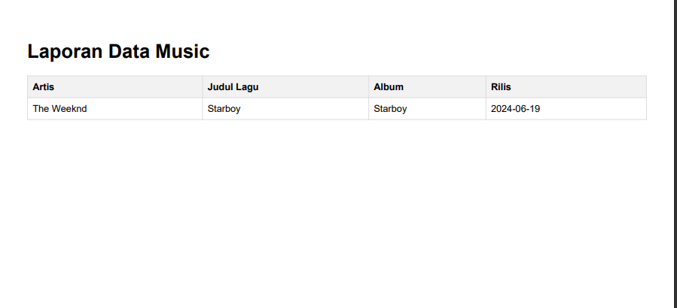

Gambar 10.1 Tampilan Report Item

Analisa :

Pada *program* diatas ditambahkan *cetak*.*blade* untuk mencetak hasil dari *report* CRUD . Selanjutnya dilakukan *route* untuk menyambungkan dari *index* button *cetak* *pdf* yang akan menampilkan hasil dari inputan *CRUD*.